Note: The ICPA should prepare the proposal using the required template attached below which differs from the template available on our website due to the unique procedures needed for this engagement. The fee proposal should be prepared using the attached spreadsheet. The legislative auditor reserves the right to refuse to consider proposals that are not submitted in this format or are incomplete.

Agency Name and Address:
Louisiana Department of Corrections
504 Mayflower Street
Baton Rouge, LA 70802
https://doc.la.gov/

Solicitation Number: 26-3342
Type of Engagement: Agreed-Upon Procedures (required procedures outlined below)
Contract Period: September 1, 2026 – December 31, 2028
Periods to be Examined: Years ending June 30, 2026; June 30, 2027; and June 30,2028
Description of the State Agency:
- The Louisiana Department of Corrections Inmate Organization Funds exist at each of the 8 state prisons and consist of branch clubs of various national, state, or local organizations. The activities include leadership and communication training, securing educational opportunities for inmates, and enhancing rehabilitation of inmates by their participation in the activities of the clubs. These activities are also intended to assist the members in becoming contributing members of society upon release. The inmate organizations pursue various fundraising avenues to pay for operating costs.
- The relevant requirements for performing the specified agreed-upon procedures specified by the Louisiana Department of Corrections are to test for proper governance, accounting system general controls, proper fiscal reporting and transaction details, and also the inspection of the inmate organizations’ records for abnormalities and irregularities.

Information related to program activities is as follows:
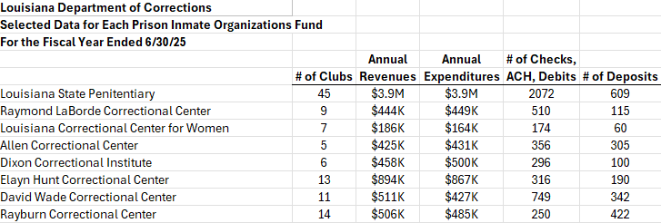

Following is the schedule of rotation for each entity during the contract period with period to be examined and required completion dates:
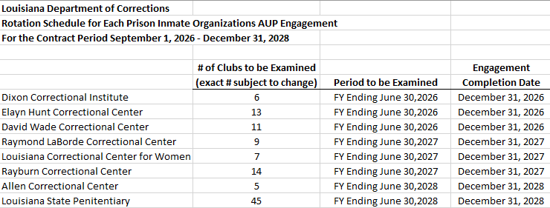

IT System(s): Quickbooks Enterprise 15.0 is used to account for the financial activities of these inmate organization funds.
State Agency Assistance / Supporting Documentation:
Each state agency will provide clubs’ organizing documents, bylaws, signature cards for bank accounts, list of Wardens, club representatives and sponsors, bank statements with reconciliations, expense receipts and backup documents, copies of deposited items and backup documents, Quickbooks financial statements, general ledger and transaction listings, and any other documents that may be required to complete the engagement.
Estimated Start of Fieldwork: No later than September 1 following each June 30 year end (see schedule of entities to be addressed for each year listed above)
Engagement Completion Date: No later than December 31 following each June 30 year end (see schedule of entities to be addressed for each year listed above)
Special Requirements:
- The successful ICPA will prepare an Agreed-Upon Procedures Report in accordance with relevant standards.
Last Engagement: Agreed-Upon Procedures for the period July 1, 2024 through June 30, 2025 (see copies of previous reports attached below)
Results of Last Engagement:
- See copies of previous reports attached below for results of each prior engagement.

Prior Auditor: McDuffie K. Herrod, LTD. Clinton, LA

Proposers’ Conference:
- A proposers’ conference will not be held.
- Any questions regarding the SFP or state agency should be sent to StateContracts@lla.la.gov

Proposal Due Date and Time: July 8, 2026 by 5:00 p.m.

Required Procedures To Be Performed (see attached file):

Most Recent Reports prepared by prior auditor (does not include Louisiana State Penitentiary not available at this time):

